**Department of Veterans Affairs**

**Innovation 873**

**Telepathology**

**VistA Imaging 3.0**

**Telepathology Worklist**

**User Manual**



**September 2015**

Revision History

| Date | Revision | Description | Author |
| --- | --- | --- | --- |
| 10 Sep 2015 | 1 | New document. | Arianna Sunbear |

Contents

1 Introduction 5

2 Telepathology Worklist Overview 5

2.1 Key Functions 5

2.2 Permissions and Logging In 6

2.2.1 Permissions 6

2.2.2 Logging In 6

2.3 Message Log 7

2.4 Getting Help 7

3 Worklist Basics 8

3.1 Worklist Tabs 8

3.2 Case Lists 9

3.3 Basic Case Reporting 10

4 Referring Cases to other Sites 11

4.1 Referring a Case for Remote Consultation 11

4.2 Monitoring in-Progress Consultations at the Referring Site 12

4.3 Verifying/Releasing a Case after Consultation 13

4.4 Recalling a Consultation 13

5 Providing Consults for other Sites 14

5.1 Entering a Consultation 14

5.2 Declining a Consultation 15

6 Reviewing Case Images 16

7 Working with Reports 16

7.1 Working with Main reports 16

7.2 Working with Supplementary Reports 17

7.3 Changing the Pathologist, Resident, or Practitioner 18

7.4 Viewing Reports 18

8 Coding Reports 19

8.1 SNOMED Coding 19

8.2 CPT Coding 20

9 Health Summary Reports 20

10 Using Notes 21

11 Using Filters 22

11.1 Temporary Filters 22

11.2 Reusable Filters 23

11.2.1 Creating or Editing Reusable Filters 23

11.2.2 Deleting Reusable Filters 23

# Introduction

This document explains how to use the VistA Imaging Telepathology Worklist as expanded in the VA Innovations 873 Program as a follow-up to patch MAG*3.0*138.

Note: This document covers telepathology-related functions of the Telepathology Worklist application only. It does not address other Lab Package capabilities.

Note: This document assumes that the Telepathology Worklist is already installed on a VA policy-compliant computer that can access the VistA system at your site, and that the Telepathology Configurator has been used to provide access to at least one other site for telepathology referrals or consultations.

This document is intended for clinical staff who refer, consult, interpret or code Anatomic Pathology (AP) cases using the VistA Imaging Telepathology Worklist as implemented for the VA Innovations 873 Program. This document assumes a general understanding of pathology workflow, the VistA MAG Package, and the VistA Lab Package.

# Telepathology Worklist Overview

The Telepathology Worklist a provides way to access and work with Surgical Pathology (SP), Cytopathology (CY) and Electron Microscopy (EM) cases that are traditionally managed using the Anatomic Pathology Menu in the VistA Lab Package.

## Key Functions

The Telepathology Worklist provides four key functions:

1. It provides a Windows-based way to perform certain pathology functions (mainly reporting and coding) for cases accessioned at your site.
2. It provides a way for your site to refer cases to other sites for consultation before finalizing an AP report.
3. It provides a way to your site to perform telepathology consultation for other site’s cases before the referring pathologist finalizes their AP report.
4. It provides a way to access pathology-related images if a commercial whole slide imaging system is set up at your site or at a site you are performing consultations for.

The first item above does not replace the similar Lab Package functions but does provide an alternate way to perform them. The last three items are only available if your site entered into a telepathology referral/consultation relationship with at least one other site, and if your site has implemented the Telepathology Worklist and Configurator.

## Permissions and Logging In

### Permissions

To access the Telepathology Worklist, you will need the following assigned to your local VistA account:

* VistA Imaging Telepathology Worklist Manager [MAGTP WORKLIST MGR] secondary menu
* MAG SYSTEM security key

To read cases (i.e., edit and complete pathology reports) you will need:

* LRLAB security key

Note: If you have the LRAPSUPER key, you will be able to override locks if you open reports form the Worklist software for editing.

### Logging In

To start the Telepathology Worklist software:

1. Go to the Start menu and choose **All Programs | VistA Imaging Programs | VistA Imaging Telepathology Worklist**.

Note: If your workstation is CCOW (Clinical Context Object Workgroup)-enabled, and if another CCOW-compliant application such as CPRS is running, you will automatically be signed in at this point. If needed, you can use the Context menu in the Worklist window to suspend or resume CCOW.

1. If the Connect To box displays, select which VistA System you want to connect to, then click **OK**.
2. In the VistA Sign-on box, enter your access and verify codes, then click **OK**. Keystrokes display as asterisks (*).
3. If the Select Division box displays, double-click the division you want to log into.

## Message Log

Use the **View | Message Log** option to view user- and system-level session log messages, and if needed to gather information for error correction.

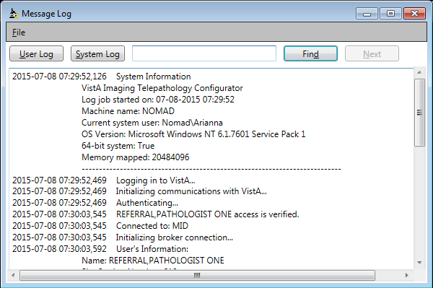

* The User Log has a white background and is shown by default.
* If you hold the MAG SYSTEM Security key, you can display the System Log by clicking **System Log**. The System Log has a tan background.
* You can search within a displayed log using the controls near the top right of the Message Log window.
* You can select and copy/paste log information from this the Message Log window into an outside text editor if needed.

## Getting Help

If you encounter problems the application, contact your local support staff. If the problem cannot be resolved locally, use Remedy to place a service request, or the VA help desk at 1-888-596-4357.

For version information for the Telepathology Worklist software , use the **Help | About** menu option.

# Worklist Basics

This section describes the purpose of each worklist tab, the columns in each worklist, and how to perform basic case reporting for a case that does not require consultation.

## Worklist Tabs

The Telepathology worklist contains three tabs: Unread, patient-specific, and Read.

* The Unread tab (shown below) lists cases that been accessioned but that have yet been released (i.e., report has not been verified). If a case has been referred for consultation, the case remains shown on the Unread tab until the referring pathologist verifies the report after completion of the consultation.
* The patient specific (middle tab) lists all cases for a specific patient once a patient is selected. To select a patent, select a case for the desired patient in either the Unread or Read tabs, and then click the middle tab. The tab will update to show the patient name and any cases associated with that patient.
* The Read tab lists entries for released cases (i.e., cases with verified reports). Cases remain listed on this tab based on the retention period defined by your site.

The contents of each tab are re-retrieved (refreshed) from VistA every three seconds. The time of the most recent refresh is shown in the lower right corner in the Worklist window.

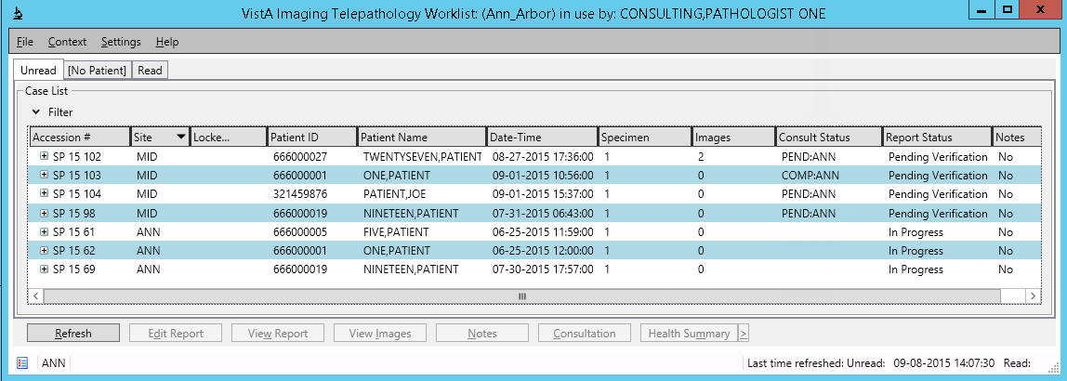

## Case Lists

Each tab contains a list of cases. This list can be sorted by clicking a column header, or filtered using the Worklist Filter box located immediately above the list of cases. For each case, the following information is shown. You can also double-click a case to show additional slide and specimen information.

*This table shows column headings in their default order. You can set your own preferred order by dragging column headings left or right if desired. If you do this, use the options under the Settings menu to decide how or if you want your changes saved.

| Column Heading* | Description |
| --- | --- |
| Accession # | The accession number for the case as set in the Lab Package |
| Site | The site (VA medical center) where the case was accessioned. |
| Locked By | If the case is locked, the initials of the person who locked the case are shown here. A lock ensures that only one person can edit a case report at a time.  Note: If you have the LRAPSUPER key, you will be able to override locks if you open reports form the Worklist software for editing. |
| Patient ID | The patient identifier (usually a social security number) |
| Patient Name | The name of the patient |
| Date-Time | The date and time that the specimens were accessioned |
| Specimen | The number of specimens in the case |
| Images | The number of whole slide images associated with the case. Note that whole slide images are stored outside of VistA, but can be accessed using the Telepathology Worklist (which calls a 3rd party viewer) if this value indicates images are present. |
| Consult Status | Shows the status of the consultation if the case has been referred to another site, and the abbreviations for the sites where the case has been referred to. Possible statuses:  PEND – consultation pending from indicated site  COMP – consultation from indicated site ready for verification  DCLN – indicated site has declined the referral  CAND – the referral was cancelled by the requesting site. |
| Report Status | Shows the status of the report for a case. The three possible statuses are:  IN PROGRESS – main report is not yet complete. PENDING VERIFICATION – main report is complete, but not yet verified. RELEASED – main report has been verified by the interpreting pathologist (case is moved from Unread to Read list) |
| Notes | Indicates if a note is present for the case. For details, see section 10.. |

## Basic Case Reporting

This section explains how Telepathology Worklist is used to finalize a case that does not require a consultation. This section applies to:

* Cases accessioned at your site (your site’s abbreviation shows in the Site column in the worklist.
* Cases from other sites that your site is authorized to verify/release reports for as the primary interpreting pathologist (the accessioning site’s abbreviation shows in the Site column of the worklist and your site is NOT indicated in the Consult Status column).

To complete/verify/release the report for a case that matches the criteria above:

1. In the Telepathology Worklist, go to the Unread tab and locate the case that you need to compete the report for.
2. If images are present, review the images for the case.
3. Review Health Summary information by right-clicking the case and choosing one of the health summary options. For details, see section 9.
4. When you are ready to complete the report, right-click the case and choose **Edit Report**.
5. In the Main tab of the report window, expand each section of the report and provide any needed information.
6. Click **Save**. (The report window will remain displayed).
7. Under the Coding tab, check for and update any needed CPT or SNOMED codes. For details, see section 8.
8. When you are finished with the report, return to the Main tab, and click **Complete**.
9. To release the case, click **Verify**, then enter your e-signature when prompted.
   * + The case status will be updated to Released, and the case will be moved to the Read list.
     + You can enter additional supplementary reports after this point, but the case status will remain unchanged.

# Referring Cases to other Sites

This section explain how to refer a case to a different site for consultation, how to monitor the progress of the consultation, and how to verify/release a case once the consultation is complete. You can also recall a consult request if necessary.

Note that once a case has been sent to one or more sites for consultation, you cannot verify the main report until the consultation is complete (or canceled) at each consulting site.

## Referring a Case for Remote Consultation

1. Go to the Unread tab in the Worklist and locate the case you want to create a referral for. Note that referrals can only be initiated for cases that are not locked.
2. Ensure that the report contains the information needed by the consulting pathologist and that is has a status of *Pending Verification*). If the report status is *In Progress*, complete the report as described in section 7.

NOTE: Do not verify (sign) the report. Once a main report has been verified, you cannot refer the case to a consultant. You can, however, enter and verify additional supplementary reports (case status will remain Released).

1. If your site is using an external whole slide imaging system that has been set up to work with the Telepathology work list, ensure that images are available for the case.
2. Optionally, add any informal comments by right-clicking a case, choosing **Notes**, and then entering a note in the bottom part of the Notes window. For more information about notes, see section 10.
3. Right-click the case and choose **Consultation**.
4. In the Consultation window, select each site that you want to request a consultation from. You can use **CTRL+click** to select more than one site if needed.
5. Click **Request**, then click **Yes** when asked for confirmation.
6. After the window closes, confirm that the Consult Status for the case shows “PEND” and the abbreviation of the sites you referred the case to.

## Monitoring in-Progress Consultations at the Referring Site

To check the status of your referrals, check the contents of the Consult Status column in the Telepathology Worklist’s Unread tab.

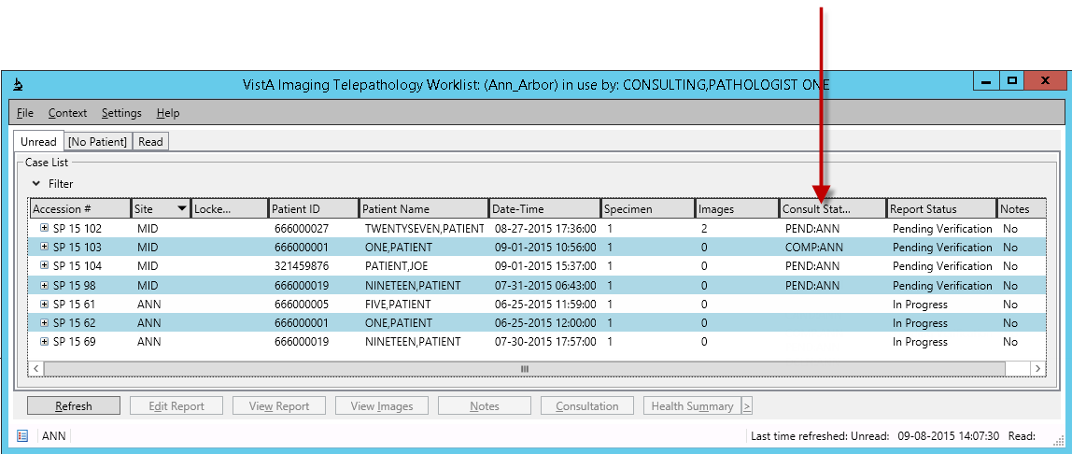

The Consult Status column will display the following information for each site that you requested a consultation from.

* COMP – The consulting pathologist has entered and verified a supplementary report.
* PEND – No action has occurred.
* DCLN - A consulting pathologist at the remote site has declined the referral.
* CAND – A local pathologist has cancelled the referral.

Typically, you will wait until the Consult Status for each consulting site is COMP, and then you can verify/release the case as described in the next section.

You can also refer the case to additional sites as described in section 4.1, or you can cancel your own referral as described in section 4.4.

## Verifying/Releasing a Case after Consultation

After a remote consultation is completed (as described in section 5.1), a case remains open and displayed in your unread list. To release a consulted-upon case:

1. In the Telepathology Worklist, go to the Unread tab and locate the case to be verified.
2. Check the Consult Status column and ensure that COMP is shown for each consulting site.
3. Right-click the case, choose **Edit Report**, and review the supplementary report information.
4. If you are satisfied with the supplementary report:
   * + Verify the supplementary report, then verify the main report (see section 7 for details).
     + After you perform both verification steps, the case will be moved to the Read list.
5. If you are not satisfied with the supplementary report, you can:
   * + Contact the consulting physician offline and work out next steps.
     + Enter additional comments in the supplementary report, then verify your comments and the main report to release the case as described above.
     + Request an additional consultations as described in section 4.1.

## Recalling a Consultation

If you need to cancel a request for consultation, do the following:

1. In the Telepathology Worklist, go to the Unread tab and locate the case that you want to cancel the consultation for.
2. Right-click the case and choose **Consultation**.
3. In the Consultation dialog that appears, select the site that you want to cancel the consultation for.
   * + If the Consultation Status shown for a specific site is Pending, the request can be cancelled.
     + If the Consultation Status is blank, there was no consultation requested.
     + If the Consultation Status is Complete, it is too late to cancel the consultation.
4. Click **Recall**, then click **Yes** to confirm the operation.

# Providing Consults for other Sites

When your site has been set up to provide telepathology consultations, consultation requests will show up as entries in your sites Telepathology Worklist’s Unread list, and will have a status of PEND followed by the abbreviation for your site.

You can:

* Review available data and document your consultation (in the form of a supplementary report) as described in section 7.2.
* You can decline the consultation as described in section 5.2.

When a supplementary report entered as a consultation is completed, it will generate a “stub case” in your VistA system that is used for workload credit.

## Entering a Consultation

1. Go to the Unread tab in the Worklist and locate the case you want to enter a consultation for. Note that consultations can only be performed for cases that are not locked.
2. Do the following:
   * + Ensure that the patient you are providing a consultation for is registered at your site (if the patient is not registered, the report for the patient will not be editable at your site).
     + Review the main report for the case by right-clicking the case and choosing **Edit Report**..
     + Review the images for the case. If the Images column in the worklist indicates that images are available, right-click the case and choose and **View Images**. For details see section 6.
     + If the Notes column indicates notes are present, right-click the case and choose and **View Notes**. For details see section 10.
     + Review Health Summary information by right-clicking the case and choosing one of the health summary options. For details, see section 9.
3. When you are ready to enter and complete your consultation:
   1. Right-click the case, choose **Edit Report**, and select the Supplementary tab.
   2. Enter your comments in the large text area under the Supplementary tab.
   3. Click **New**. Your comments will show as a new entry on the right side of the tab (for additional details about working with supplementary reports, see section 7.2).
   4. To finalize your consultation, click your entry on the right side of the tab, and click **Complete**.
   5. Click **Yes** to acknowledge the notice about the reference record.
   6. Click **Close.**
4. Check the Unread list and verify that the Consult Status for your site is “COMP”.
   * + The case will remain on your site’s Unread list until the referring site verifies your supplementary report and their main report.
     + After the referring site verifies and completes the report, the case status is updated to Released and the case is moved to the Read list.

## Declining a Consultation

To decline a consultation:

1. In the Unread list, right-click the entry for the case you want to decline and choose **Consultation**.
2. Click **OK** when the notice box below displays:

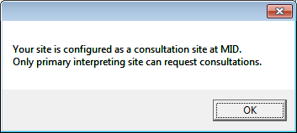

1. Click **Yes** when the notice box shown below displays:

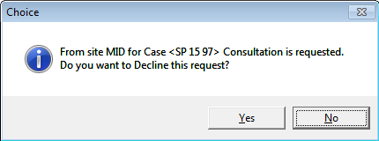

1. After the consultation is declined, the case is removed from your Unread list.

# Reviewing Case Images

If a case has one or more images associated with it, you can display those images by right-clicking the case and choosing **View Images**.

Note: It is the responsibility of the user to determine if image quality is sufficient for diagnosis and to adhere to manufacturer guidelines for indications for use for third-party software

Images for a case will be displayed in the whole slide image viewer software installed on your workstation.

If Aperio ImageScope is the software being used:

* This software includes standard image manipulation and annotation tools. Annotations are overlaid and will be visible to other users who display the images. For details about using specific tools, choose **Help | About** in the Aperio ImageScope window.
* These images are stored in a commercial whole slide imaging system, not VistA, and are not displayable using the VistA Imaging Clinical Display software.
* If there were already images displayed in the ImageScope software, the newly selected images will replace the existing images.

# Working with Reports

You can edit, complete, and verify the main report and supplementary reports using the Telepathology worklist software as described in this section. Once the report is completed, you can view a copy of the report as it will appear in CPRS.

You can also add SNOMED and CPT codes as described in section 8.

## Working with Main reports

1. Go to one of the tabs in the Worklist and locate the case associated with the report you want to work on.
2. Right-click the case and choose **Edit Report**.
3. Check the Information area at the top of the report. Fields with an ellipsis (…) can be edited as described in section 7.3.
4. Under the Main tab, click  or  to expand or collapse each section of the report. Enter any needed information.
5. When you are finished with the main part of the report, click **Save**. (The report window will remain displayed).
6. If you plan on completing the report, ensure that the any needed CPT or SNOMED codes are entered under the Coding tab. For details, see section 8.
7. When you are finished with the report, return to the Main tab, and click **Complete**.

Note: At this point, the main report can no longer be edited, but the case is awaiting verification. At this point, if enabled, the case could be referred for consultation at another site as described in section 4.1.

1. When you are ready to release the case, click **Verify**, then enter your e-signature when prompted.
   * + The case status will be updated to Released, and the case will be moved to the Read list.
     + You can enter additional supplementary reports after this point, but the case status will remain unchanged.

## Working with Supplementary Reports

A pathologist with access to a case can use the Telepathology Worklist to enter a supplementary report. In cases that involve a consultation, the supplementary report is where the consulting pathologist will enter their comments and/or findings.

1. Go to one of the tabs in the Worklist and locate the case associated with the report you want to work on.
2. Right-click the case, choose **Edit Report**, and select the Supplementary tab.
3. To create a new supplementary report entry:
   1. If desired, use the Supplementary Report Date box immediately under the tab to set the date for up to 2 weeks before the current date.
   2. Enter your text in the large text area on the left of the tab.
   3. When you ready to apply your text, click **New** and your entry will be added to the report and shown on the right side of the tab.
4. To change an existing supplementary report entry:
   1. Select the entry from the right side of the tab (entries with a Verified value of Yes cannot be changed).
   2. Edit the text that is displayed on the left side of the tab.
   3. When you ready to apply your text, click **Update** and your changes will be applied to the existing on the right side of the tab.
5. To finalize an entry, select the entry on the right side of the tab and click **Verify**.
6. When you are finished working with supplementary reports, click **Close.**

## Changing the Pathologist, Resident, or Practitioner

Up until a main report is verified, you can change which Pathologist, Resident, or Practitioner is associated with the report.

1. If it is not open already, right-click the case associated with the report you want to edit and choose **Edit Report**.
2. In the top right part of the report window, click the ellipsis (…) button to the right of the name you want to change.
3. In the Select User box that displays, enter two or more characters of the person’s name, then click **Search User**.
4. Click the Select A User list and select the name you want to use, then click **OK**.

Note: Once a name has been selected for the Pathologist, Resident, or Practitioner fields, and after the report is saved, the name can be changed but not removed from the report.

1. Confirm that the name appears as desired in the upper right corner of the report, then click **Save**.

## Viewing Reports

To view a report, go to the Read tab and select the case associated with the report you want to view. Then click **View Report** (located near the bottom of the window), or right-click and choose **View Report**.

Note that this option is only available for verified (released) reports.

# Coding Reports

The Telepathology Worklist provides a Windows-based way to add coding to reports. Both SNOMED (Systematized Nomenclature of Medicine) and CPT (Current Procedural Terminology) coding can be performed.

If any coding was performed within the Lab Package roll-and-scroll interface, that information is shown when a report is opened from the Telepathology Worklist.

## SNOMED Coding

SNOMED codes can be added to a report for any case accessed from the Telepathology Worklist. To add SNOMED codes:

1. In the Worklist, select the case that needs coding and choose **Edit Report**.
2. In the Reporting dialog, select the Coding tab and the SNOMED subtab.
3. For each organ/tissue that needs to be coded, do the following:
   1. In the search box, enter two or more characters from the name of the organ or tissue, then click **Search**.
   2. Click the pull-down list, select the desired organ or tissue, then click **Add**. The selected organ or tissue will display on the left side of the tab.
   3. On the left side of the list, double-click the organ/tissue that you selected.
   4. Select the sub-item that requires additional information, and use the search box and pull down list as described in the steps above to add the needed information for that item.

**Note:**  Adding information for Morphologies generates a new sub-item for one or more Etiologies.

1. If you need to add an additional organ or tissue, click **Clear Selection**, then repeat step 3 above.
2. As you work with the SNOMED tab you can:
   * + Double-click a row or single click the icons next to an item to expand or collapse that item.
     + Remove an item and all (and all sub items under that item) by selecting the item and clicking **Remove**.
3. When you are finished, click **Close** to close the Reporting dialog. Any values shown on the left side of the SNOMED subtab will be saved automatically.

## CPT Coding

To edit CPT codes:

1. In the Worklist, select the case that needs coding and choose **Edit Report**.
2. In the Reporting dialog, select the Coding tab and the CPT subtab.
3. In the Search Location box, specify the applicable location by entering two or more characters and clicking **Search**.
4. After the pull-down box is populated, click the box and select a location.
5. In the bottom box in the tab, enter one or more CPT codes.
   * + You can enter multiple codes separated by commas.
     + You can enter a multiplier for a code by adding an asterisk and the multiple value after the code and before the comma for the next code.
     + Entering a code that is already present on the list near the top of the CPT subtab will increase the multiplier by one.
6. Verify that the data you entered is correct (once added, the software has no way to remove a CPT code).
7. Click **Add** to apply the codes to the report.

# Health Summary Reports

Health summary reports are a collection of site-defined reports generated by the Health Summary Package. Using the Telepathology Worklist, you can access any health summary report available at your site. You can also designate a default health summary report and define a personal collection of frequently used health summary reports.

To open a specific Health Summary report:

1. Right-click the case that you want to view health summaries for and choose **View Health Summary List**.
2. In the window that displays, locate the report you want to display and click **View Health Summary**.

To define a list of frequently used reports or a default report:

1. Right-click any case in the Worklist window choose **View Health Summary List**.
2. For each report that you want to access frequently, locate that report in the Available Reports area in the bottom part of the window, and click **Add**.
3. If you want to designate a default report, first add that report to the Select Reports area as described in the previous step. Then select that report and click **Set Default**.

# Using Notes

You can use notes to share comments or communicate informally with the other pathologists who have access to a case in Telepathology Worklist. These notes are specific to the Worklist software, and are not accessible using the Lab Package or CPRS.

A “Yes” value in the Notes column of the Worklist window indicates that a note is present.

To view the notes for a case, right-click that case and choose the **View Notes** option, or click a case and then click the **Notes** button near the bottom of the Worklist window.

To add a note to a case, right-click case that you want to enter a note for, then click **View Notes**. In the bottom of the Notes window, enter the text for the note, then click **Add**.

Note: After **Add** is clicked, the text you entered cannot be changed or removed.

Notes are not part of the formal report. Notes are stored in the MAG PATH CASELIST File (#2005.42) and are accessible for as long as a case is shown in any Worklist tab.

# Using Filters

In each Worklist tab, there is an area above the worklist that shows the active filter. You can use the controls in this area to select a different filter (1), create a temporary filter (2) , or clear a currently applied filter (3). You can also show or hide the filter area by clicking the small expand/collapse icon near the top left corner of the filter area (4).

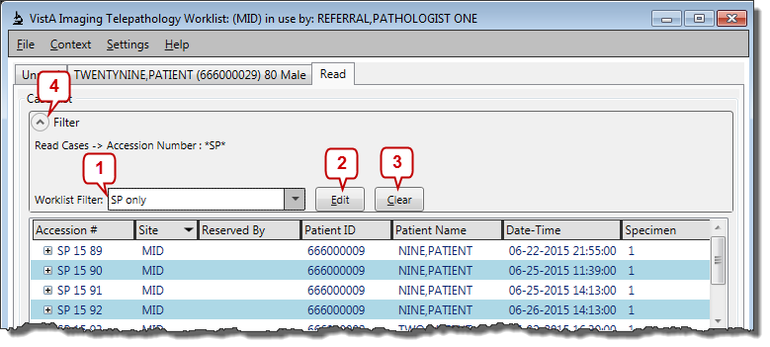

Each tab in the worklist can use a different filter.

## Temporary Filters

Use temporary filters you only need to filter a list for the current login-session.

Note: The only way to convert a temporary filter into a reusable filter is to recreate the filter settings in a new reusable filter (known issue) .

1. In the Worklist tab where you want to apply the temporary filter, click the **Edit** button in the Filter area (expand the area by clicking  if the filter controls are currently hidden.)
2. In the Filter Settings window that displays, use the controls on the right side of the Filter Settings window to define one or more filter parameters.
   * + The left column lists each property you can base a filter on. These correspond to the columns in each case list and are described in section 3.2.
     + For each filter parameter you want to define, enter a value in the right column, and use the pull-down box in the center column do determine how the value should be compared to the property on the left.
3. When you are finished, click **Apply**. The temporary filter will be applied to the currently displayed Worklist tab.

## Reusable Filters

Use the steps below to create a reusable filter that can be selected from the Worklist Filter box. Reusable filters in the (MAG PATH CONFIG file (#2006.13) under USER PREFERENCES (multiple 2006.137)) and will be available wherever you use the Worklist software.

### Creating or Editing Reusable Filters

1. In the Telepathology worklist application, choose **Settings | Filter Settings**.
2. In the Filter Settings window that displays, do one of the following:
   * + To create a new filter, click **New** near the bottom of the window, then enter the name of the new filter into the Name box near the top of the window. (Be aware that once new filter is saved, the name of the filter cannot be changed.)
     + To edit a filter, select the filter that you want to edit from the list on the left side of the window, and then click Edit near the bottom of the window.
3. Use the controls on the right side of the Filter Settings window to define one or more filter parameters.
   * + The left column lists each property you can base a filter on. These correspond to the columns in each case list and are described in section 3.2.
     + For each filter parameter you want to define, enter a value in the right column, and use the pull-down box in the center column do determine how the value should be compared to the property on the left.
4. When you are finished, click **Save**. The new or edited filer can be used immediately.

Note: Clicking **Save** in the Filter Settings dialog will remove any temporary filters applied to the worklist (known issue).

### Deleting Reusable Filters

1. In the Telepathology worklist application, choose **Settings | Filter Settings**.
2. In the Filter Settings window that displays, select the filter you want to delete from the list shown on the left side of the window, then click **Delete**.

Note: Clicking **Delete** in the Filter Settings dialog will remove any temporary filters applied to the worklist (known issue).

1. Click yes when you are asked for confirmation and then click **Close**.